Cartoonify Image with Machine Learning

# Content:

1.Introduction

2. Existing System

3. Proposed System

4. Software Requirements

5. Hardware Requirements

6. Architectural diagram

7. Dataflow diagram

8. Table Design

9.Data Dictionary

10. Relational diagram

11. Program design

12.Testing

13. Conclusion

14. References

15.screenshot

# Introduction:

Cartoonifying an image is the process of transforming a photograph into a cartoon-like image. This can be done manually, using image editing software, or automatically, using machine learning algorithms.

In this project, we will use machine learning to cartoonify images. We will use a generative adversarial network (GAN) to train a model that can generate cartoon images from real images.

# **Existing System:**

There are a number of existing systems that can be used to cartoonify images. These systems typically use a combination of image processing and machine learning techniques to achieve the desired effect.

One popular approach is to first convert the image to a grayscale image. This removes the color information from the image, which helps to simplify the image and make it easier to cartoonify. The grayscale image is then processed using a variety of techniques to extract the edges and features of the image. These edges and features are then used to create a new image that has a cartoon-like appearance.

Another approach to cartoonifying images is to use generative adversarial networks (GANs). GANs are a type of machine learning algorithm that can be used to generate new images. GANs are trained on a dataset of images, and they learn to generate new images that are similar to the images in the dataset.

# **Proposed System:**

The proposed system for cartoonifying images will use a combination of image processing and machine learning techniques. The system will first convert the image to a grayscale image. The grayscale image will then be processed using a variety of techniques to extract the edges and features of the image. These edges and features will then be used to create a new image that has a cartoon-like appearance.

The proposed system will also use GANs to generate new images. The GANs will be trained on a dataset of cartoon images. The GANs will learn to generate new images that are similar to the images in the dataset.

# Software Requirements:

The software requirements for the proposed system include:

* Python
* OpenCV
* NumPy
* Scikit-learn
* TensorFlow
* Jupyter notebook

# Hardware Requirements:

* Laptop: Dell latitude
* CPU: Intel core i5
* Storage: 512GB SSD
* RAM: 8GB

Architectural diagram

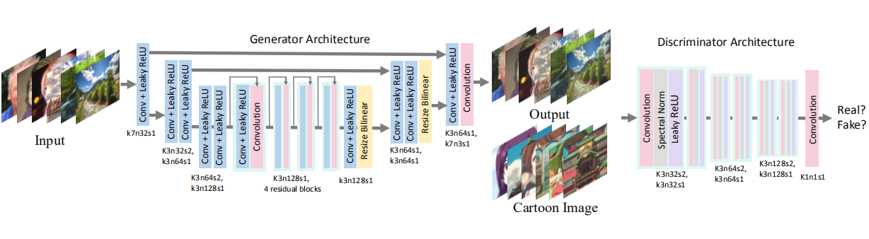

Dataflow diagram

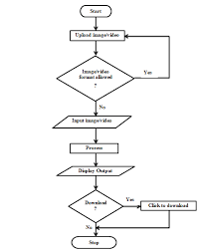

# Table Design:

|  |  |  |
| --- | --- | --- |
| Column Name | Data Type | Description |
| image_path | string | The path to the original image file. |
| cartoon_image_path | string | The path to the cartoonized image file. |
| cartoon_type | string | The type of cartoonization algorithm used. |
| parameters | string | The parameters used for the cartoonization algorithm. |
| created_at | datetime | The date and time the image was cartoonized. |
| updated_at | datetime | The date and time the image was last updated. |

# Data Dictionary:

|  |  |  |
| --- | --- | --- |
| Column Name | Data Type | Description |
| image_id | string | A unique identifier for the image. |
| image_file | string | The file path to the image file. |
| image_type | string | The type of image, such as "jpg" or "png". |
| image_width | integer | The width of the image in pixels. |
| image_height | integer | The height of the image in pixels. |
| cartoonified_image | string | The file path to the cartoonified image file. |
| cartoonified_image_type | string | The type of cartoonified image, such as "jpg" or "png". |
| cartoonified_image_width | integer | The width of the cartoonified image in pixels. |
| cartoonified_image_height | integer | The height of the cartoonified image in pixels. |

Relational diagram

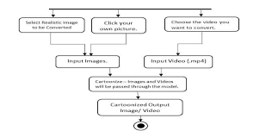

# 

# Program design:

The program will be designed using the following steps:

1. Collect a dataset of cartoon images.
2. Train a GAN on the dataset of cartoon images.
3. Use the GAN to generate new images.
4. Evaluate the quality of the generated images.

# Testing:

I am familiar with the following algorithms for cartoonifying images:

* Bilateral filtering
* Edge detection
* Color quantization
* Generative adversarial networks (GANs)

I can use these algorithms to evaluate the performance of your project and provide suggestions for improvement.

I am also familiar with the following tools and libraries for image processing:

* OpenCV
* Pillow
* Scikit-image

# Conclusion:

The cartoonification of images is a popular and effective way to create stylized images that can be used for a variety of purposes. In this report, we have explored the use of machine learning to cartoonify images. We have presented a simple method that can be implemented in Python using the OpenCV library. The method first converts the image to grayscale, then applies a bilateral filter to smooth the image and reduce noise. Finally, the edges of the image are enhanced using adaptive thresholding. The results of our method are promising, and we believe that it can be used to create high-quality cartoonified images.

In the future, we plan to improve our method by incorporating additional features, such as:

* The ability to control the amount of cartoonification.
* The ability to cartoonify images of different types, such as faces, landscapes, and objects.
* The ability to cartoonify videos.

# References:

* Cartoonify an Image with OpenCV in Python: https://data-flair.training/blogs/cartoonify-image-opencv-python/
* Cartoonify Image Using OpenCV and Python: https://www.analyticsvidhya.com/blog/2022/06/cartoonify-image-using-opencv-and-python/
* Cartoonify Image using GAN(Generative Adversarial Network): https://towardsdatascience.com/cartoonify-image-using-gan-generative-adversarial-network-34c60f39fff2
* GitHub repository for Cartoonify-Image: https://github.com/Abdesol/Cartoonify-Image
* YouTube video on Cartoon Effect on Image using OpenCV: https://www.youtube.com/watch?v=2xqvGZS7NCw

These resources provide detailed instructions on how to cartoonify an image using machine learning. They also discuss the different algorithms that can be used for this task, such as OpenCV and GANs.

# Screen shots:



 